**26.4 IaaS**

Collectively, the elements we have been discussing are the foundation for IaaS (Infrastructure as a Service). IaaS is a form of cloud computing, which is the delivery of on-demand shared computing resources (software and/or data) to organizations and users through the internet.

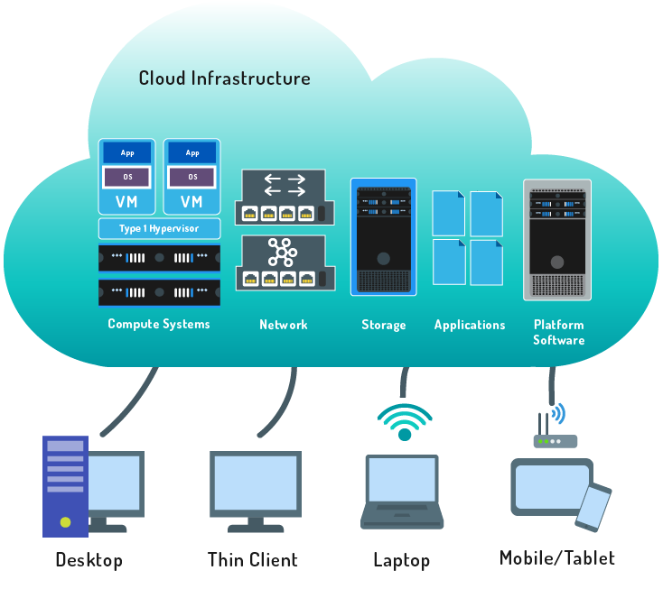

Cloud computing is a popular subject for discussion, and both organizations and individuals show a keen interest in the advantages it can provide. As soon as it became feasible for computer systems to create and manage other computer systems through virtualization and automation, programmers and system designers gravitated towards software-defined systems and networking. As a result, organizations are increasingly looking at the cloud as essential to their businesses and operations.

**Consider This**

You often hear that something is "in the cloud", but what does that mean? Physically, a cloud can be described as computing resources from one or many off-site data centers which can be accessed over the internet.

By abstracting the machines being managed from physical hardware, it becomes possible and desirable to construct systems in software as much as possible. By placing virtual machine *instances* on hardware managed by hypervisors and networking them together using software, not only were physical demands reduced but speeds were increased, as each part of a system only had to communicate within the APIs (application programming interfaces) of an orchestrating technology. **Orchestrating systems** such as OpenStack, Apache Cloudstack, and OpenNebula has made cloud computing possible.

These systems have been able to advance quickly because open source software development allows different, often competing, companies to work together to create common standards and code bases. Each of these projects is broken down into smaller sub-projects, which can be developed by teams that specialize in a specific technical area. By working together, and sharing improvements in the code, they are able to construct robust systems that are adaptable to many different needs.

Linux VMs have the ability to communicate with Linux containers, block storage pools, virtual network switches and routers, database stores, and every other component that was once part of a monolithic program or data center design. Ultimately, by creating hypervisors that run Linux VMs, today’s programmers and system architects have collaboratively created our modern online world in much less time and with far fewer resources than any one company could have achieved.